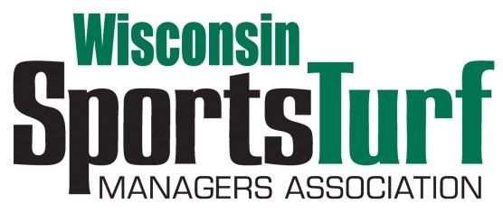
WISCONSIN SPORTS TURF ASSOCIATION
PARTNERSHIP PROGRAM, 2018

Platinum Level Partnership $2,000.00
- Full page advertisement in WSTMA newsletter
- Website listing on WSTMA website
- Platinum meeting sponsorships of two WSTMA events
- 3 Annual Membership dues paid as part of package, please email names and email addressed to Pete Bemis
- 3 Meeting Registrations paid as part of package for two WSTMA events
- Outdoor Display Space for two meetings
- Booth--2 Tabletops for two meetings
- Company Logo on registration form
- Presentation of Main Speaker at Winter meeting

Gold Level Partnership $1,550.00
- One-half page advertisement in WSTMA newsletters
- Website listing on WSTMA website
- Gold meeting sponsorships of two WSTMA events
- 2 Annual Membership dues paid as part of package, please email names and email addresses to Pete Bemis
- 2 Meeting Registrations paid as part of package for two WSTMA events
- Outdoor Display Space for Fall Meeting
- Booth--1 Tabletop for two meetings
- Company Logo on registration form
-page one of two-

Silver Level Partnership $995.00
- Business card advertisement in WSTMA newsletters
- Website listing on WSTMA website
- Silver meeting sponsorships of two WSTMA events
- 1 Annual Membership dues paid as part of package
- 1 Meeting Registration paid as part of package for two WSTMA events
- Booth--1 Tabletop for two meetings
- Company Logo on registration form

Bronze Level Partnership $670.00
- Business card advertisement in WSTMA newsletters
- Bronze meeting sponsorships of two WSTMA events
- 1 Annual Membership dues paid as part of package
- 1 Meeting Registration paid as part of package for two WSTMA events
- Booth—1 Tabletop for two meetings
- Company name on registration form

Green Grass Level Partnership $345.00
- Green Grass meeting sponsorships of two WSTMA events
- 1 Annual Membership dues paid as part of package
- Company name on registration form
- No meeting registration included
- No booth tables for displays at any events

Payment can be made via the website: www.wstma.org, or by requesting to be invoiced, or my mailing a check to the following;

Chapter Manager, Pete Bemis
2206 Park Drive
La Crosse, WI 54601
608-792-9264
pbemis@wstma.org

-page two of two-

