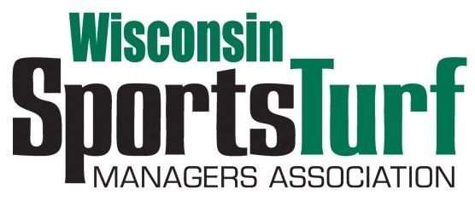

WISCONSIN SPORTS TURF ASSOCIATION
PARTNERSHIP PROGRAM, 2023

Platinum Level Partnership $2300.00
- Full page advertisement in WSTMA newsletter
- Website listing
- Platinum meeting sponsorships of two WSTMA events
- 3 Annual Membership dues paid as part of package
- 3 Meeting Registrations paid as part of package for two WSTMA events
- Recognition at Networking Events and Conference Breakfast Sponsorship
- Outdoor Display Space for two meetings
- Booth--2 Tabletops for two meetings
- Membership access to website and member directory
- Free job posting on website and an email to all members with position description and salary range

Gold Level Partnership $1,805.00
- One-half page advertisement in WSTMA newsletters
- Website listing
- Gold meeting sponsorships of two WSTMA events
- 2 Annual Membership dues paid as part of package
- 2 Meeting Registrations paid as part of package for two WSTMA events
- Recognition at Networking Events and Conference Breakfast Sponsorship
- Outdoor Display Space for Fall Meeting
- Membership access to website and member directory
- Booth--1 Tabletop for two meetings
- Free job posting on website and an email to all members with position description and salary range

Silver Level Partnership $1095.00
- Business card advertisement in WSTMA newsletters
- Website listing
- Silver meeting sponsorships of two WSTMA events
- 1 Annual Membership dues paid as part of package
- 1 Meeting Registration paid as part of package for two WSTMA events
- Membership access to website and member directory
- Booth--1 Tabletop for two meetings
- Free job posting on website and an email to all members with position description and salary range

Bronze Level Partnership $737.00
- Business card advertisement in WSTMA newsletters
- Bronze meeting sponsorships of two WSTMA events
- 1 Annual Membership dues paid as part of package
- 1 Meeting Registration paid as part of package for two WSTMA events
- Membership access to website and member directory
- Booth—1 Tabletop for two meetings
- Free job posting on website and an email to all members with position description and salary range

Green Grass Level Partnership $385.00
- Green Grass meeting sponsorships of two WSTMA events
- 1 Annual Membership dues paid as part of package
- Membership access to website and member directory
- No meeting registration included
- No booth tables for displays at any events
- Free job posting on website and an email to all members with position description and salary range

-page two of three-

WSTMA
Partnership Program Registration for 2023

Registration can also be completed on line: https://wstma.wildapricot.org/page-1770103

Agency name: ______________________________________________
Partnership level: ___________________________________________

Main contact person: ________________________________________
Address: __________________________________________________
City, State, Zip: _____________________________________________
Telephone: ________________________________________________
E-mail address: ____________________________________________

2nd contact for Platinum members and Gold members
Name: ___________________________________________________
Address: _________________________________________________
City, State, Zip: ____________________________________________
Telephone: __________________ Email: _______________________

3rd contact for Platinum members
Name: ___________________________________________________
Address: _________________________________________________
City, State, Zip: ____________________________________________
Telephone: __________________ Email: _______________________

Checks can be mailed to:
WSTMA
Michael Krupke
705 ½ E. 2nd Ave
Brodhead, WI 53520
If you wish to have an invoice sent, or have other questions,please contact: Michael Krupke (608) 671-4383

