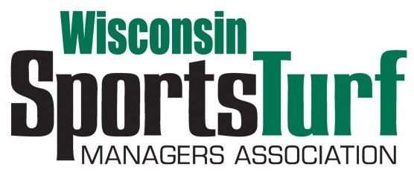

WISCONSIN SPORTS TURF ASSOCIATION
PARTNERSHIP PROGRAM, 2020
Prices remain the same for the fourth year!

Platinum Level Partnership $2,000.00
- Full page advertisement in WSTMA newsletter
- Website listing
- Platinum meeting sponsorships of two WSTMA events
- 3 Annual Membership dues paid as part of package
- 3 Meeting Registrations paid as part of package for two WSTMA events
- Outdoor Display Space for two meetings
- Booth--2 Tabletops for two meetings
- Membership access to website and member directory
- Free job posting on website and an email to all members with position description and salary range

Gold Level Partnership $1,550.00
- One-half page advertisement in WSTMA newsletters
- Website listing
- Gold meeting sponsorships of two WSTMA events
- 2 Annual Membership dues paid as part of package
- 2 Meeting Registrations paid as part of package for two WSTMA events
- Outdoor Display Space for Fall Meeting
- Membership access to website and member directory
- Booth--1 Tabletop for two meetings
- Free job posting on website and an email to all members with position description and salary range
-page one of three-

Silver Level Partnership $995.00
- Business card advertisement in WSTMA newsletters
- Website listing
- Silver meeting sponsorships of two WSTMA events
- 1 Annual Membership dues paid as part of package
- 1 Meeting Registration paid as part of package for two WSTMA events
- Membership access to website and member directory
- Booth--1 Tabletop for two meetings
- Free job posting on website and an email to all members with position description and salary range

Bronze Level Partnership $670.00
- Business card advertisement in WSTMA newsletters
- Bronze meeting sponsorships of two WSTMA events
- 1 Annual Membership dues paid as part of package
- 1 Meeting Registration paid as part of package for two WSTMA events
- Membership access to website and member directory
- Booth—1 Tabletop for two meetings
- Free job posting on website and an email to all members with position description and salary range

Green Grass Level Partnership $345.00
- Green Grass meeting sponsorships of two WSTMA events
- 1 Annual Membership dues paid as part of package
- Membership access to website and member directory
- No meeting registration included
- No booth tables for displays at any events
- Free job posting on website and an email to all members with position description and salary range

Thank you for your support of the WSTMA!
Questions? Contact Pete Bemis, Chapter Manager, pbemis@wstma.org

Checks can be forwarded to: WSTMA, Pete Bemis, 2206 Park Drive, La Crosse, WI 54601

-page two of three-

WSTMA
Partnership Program Registration for 2020

Registration can also be completed on line: https://wstma.wildapricot.org/page-1770103

Agency name: ______________________________________________
Partnership level: ___________________________________________

Main contact person: ________________________________________
Address: __________________________________________________
City, State, Zip: _____________________________________________
Telephone: ________________________________________________
E-mail address: ____________________________________________

2nd contact for Platinum members and Gold members
Name: ___________________________________________________
Address: _________________________________________________
City, State, Zip: ____________________________________________
Telephone: __________________ Email: _______________________

3rd contact for Platinum members
Name: ___________________________________________________
Address: _________________________________________________
City, State, Zip: ____________________________________________
Telephone: __________________ Email: _______________________

Checks can be mailed to:
WSTMA
Pete Bemis
2206 Park Drive
La Crosse, WI 54601

If you wish to have an invoice sent, or have other questions, please contact: Pete Bemis, 608-792-9264, pbemis@wstma.org

-page three of three-

